Hearn Family Collection of Writing and Printing
Donated by Lily Kristjanson Hearn

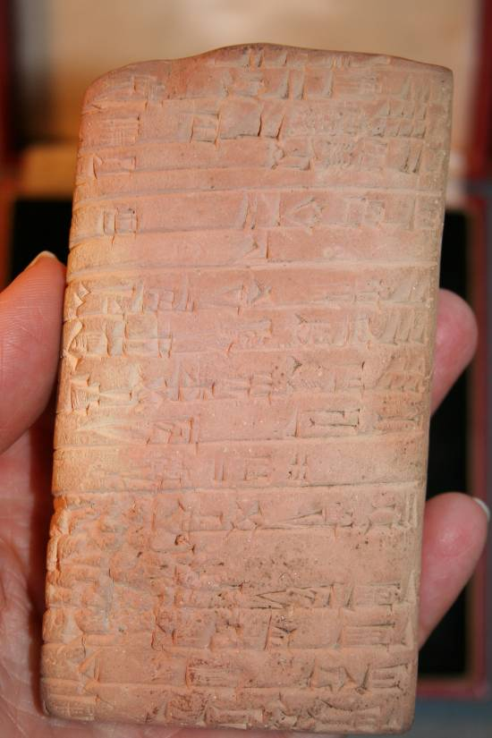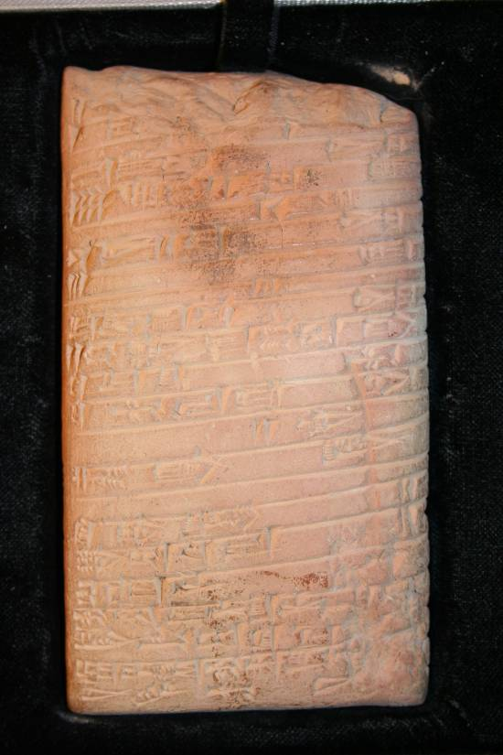

Cuneiform Tablet on Sumerian Clay, recording the receipt and issue of grass-fed sheep and two bear-cubs from one office at Drehem. Bottom edge defective on reverse, 2 3/8 by 4 ¼ inches, enclosed in a case with name of former owner. Drehem, dated the 16th day of the 10th month of the 5th year of Shu-Sin, (2034 B.C.)

A large tablet which was published in transliteration as number 91 in “Sumerian Economic Texts from the Third Dynasty of Ur” by T.B Jones and J.W. Snyder (Minneapolis, 1961) From the archives of the rulers of the Third Dynasty of Ur, which restored prosperity to the empire in the neo-Sumerian period. Bear cubs appear quite frequently in the Drehem records. They seem to have been kept for food, but it is not clear whether they were being raised in captivity, or were wild bears that had been caught.

Source: Dawson’s Book Shop: Catalogue 423: Original Examples to Illustrate the History of Writing and Printing (April, 1974) purchased for $500.00.

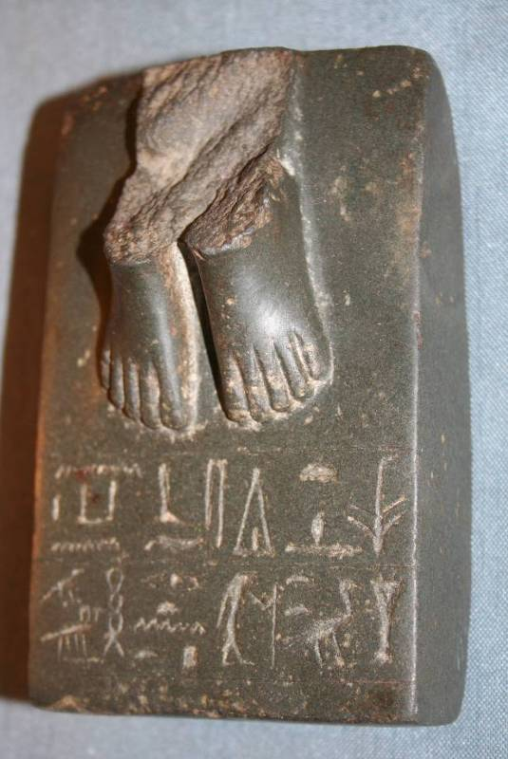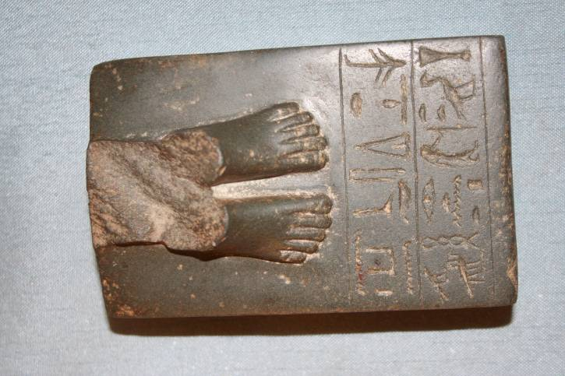

Egyptian Hieroglyphic on Stone
Writing on Stone, Base of a black granite figure inscribed with a dedication to the Crodcodile God Sobek. 3 by 43/4 inches with the feet of the figure weight nearly two pounds. Egypt, 13th Dynasty (circa 1785-1660 B.C.) Inscription in hieroglyphic translated: Invocation of the God Sobek, done for Satetbastet (or possibly the longer-Satetwerebastet) daughter of Ptah-Werwbau. There is another inscription whiche ends with the name of her father. Possibly from Fayum. Purchased for $500 in 1974. Source: Dawson’s Book Shop: Catalogue 432: Original Examples to Illustrate the History of Writing and Printing.

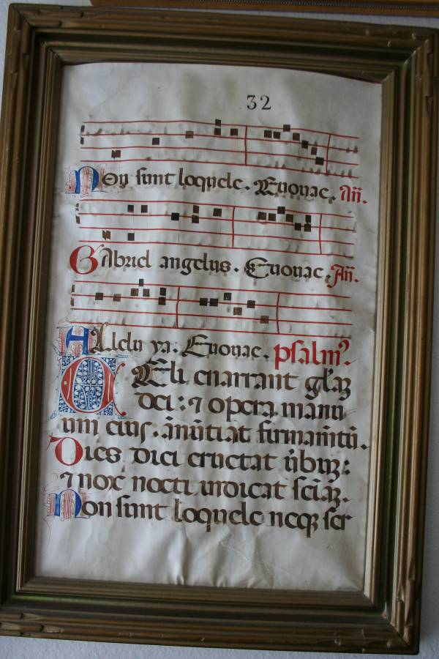
Medieval Manuscript
Vellum page (illuminated) from a 13th or 14th century missal. Psalter page? From Book of Psalms? Oxford Universal Dictionary. (Authenticated informally by a curator of Huntington Library and later at Princeton University) 12” x 19”.

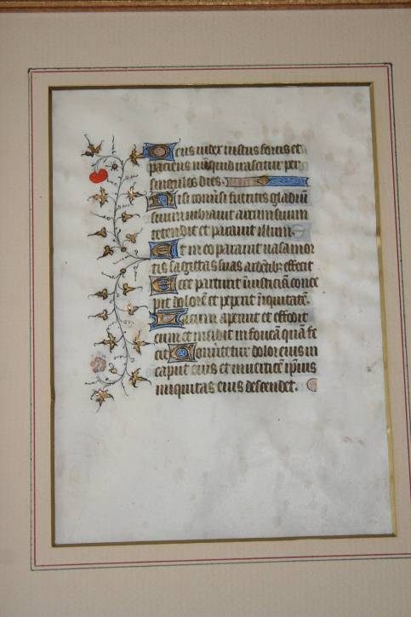
Page from “Book of Hours from 15th Century Illuminated Manuscript . Written on vellum in a bold Gothic hand. This leaf is illuminated with elaborate marginal floriation, gold and colors…probably from Southern Netherlands in the late 14th century.”

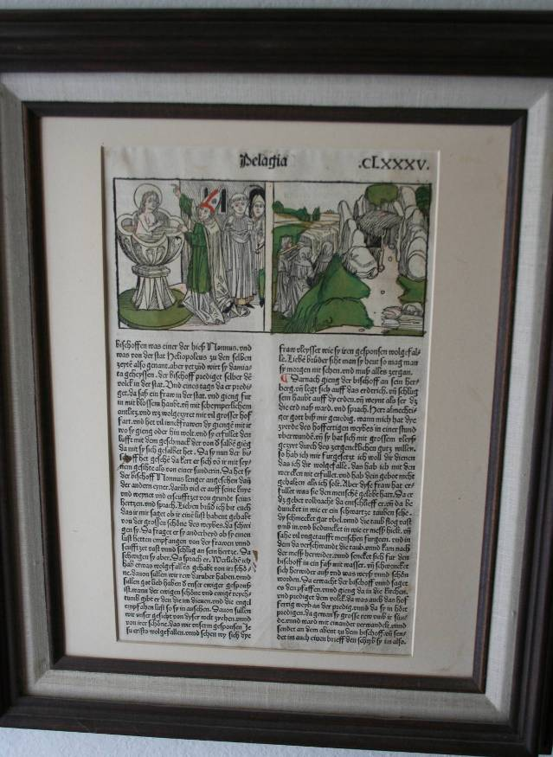
Nuremberg Printing
December 1488 An example of “Incunabula” a book printed before 1501, during the first 50 years of printing.” Printed on front and back.

This one: “Leaves from the Golden Legend” or “Lives of the Saints” by Jacob De Voregine.

Printed in Nuremberg by Anton Koberger, December, 1488.

9” x 13”. Printed in two columns. The capital an intial strokes are in red, the paragraph marks are in red and blue. The wood engravings are painted by hand.
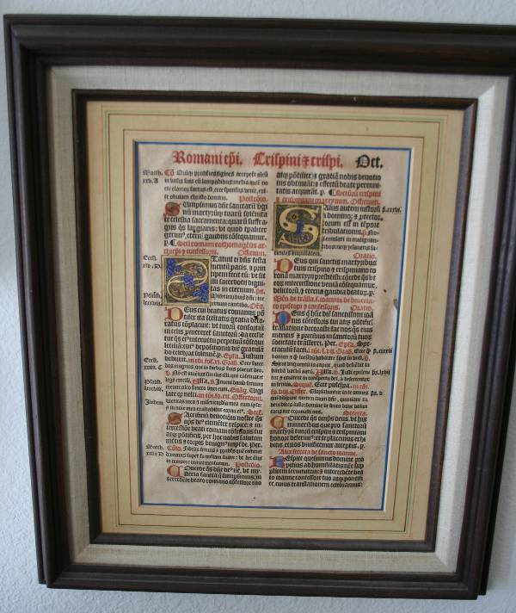

Romaniepi
Illuminated Manuscript, 8” x 11.5”
Possibly from the Nuremburg Chronicle, 15th Century-Medieval Period?

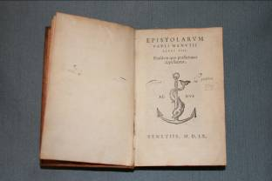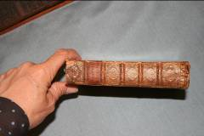

Aldus (Aldine Press) Book MDLX (1560) Early Print
Epistolarvm, Pavli ManvTII Libri III, Eiufdemquaepraefationes appelantur.
4” x 6” in great condition and leather binding with date of 1560.
Printing by movable type was invented in Germany in the 1450’s (attributed to Gutenberg). Aldus Manutius (1450-1515). Italian scholar and printer and founder of the Aldine Press-- with the fish and anchors symbol on title page. Succeeded by his son “Italian printer and classical scholar, founded the Aldine Press.” “His son Paulus (1512-1574) succeeded in management of the Aldine Press…” Webster’s Biographical Dictionary.
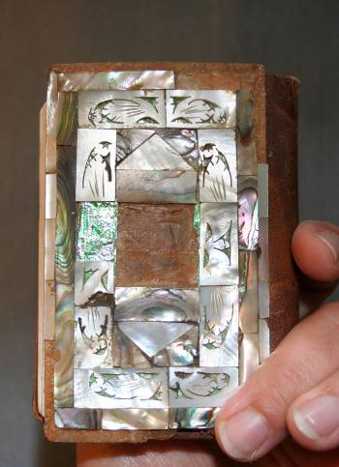
Koran with Mother of Pearl hand carved tiles on leather binding measures 3” x 4” with Arabic writing. Example of early printing.
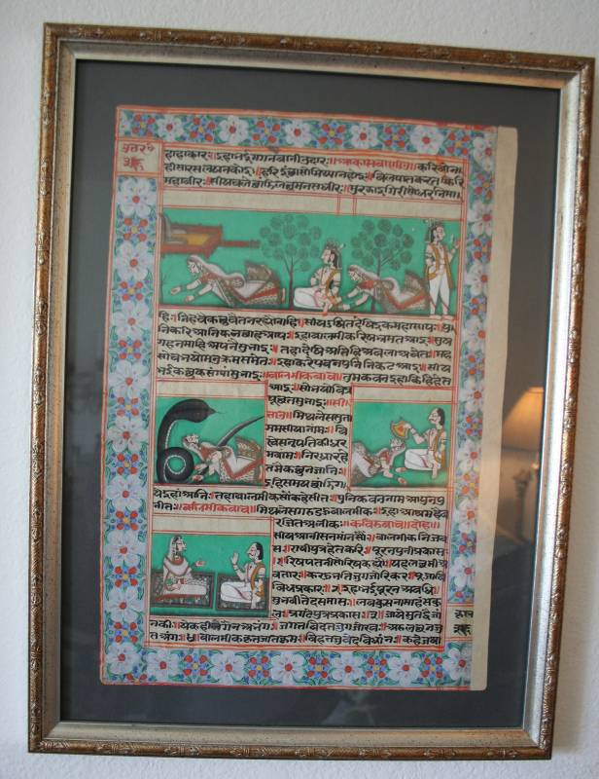
Ramayana (Sanskrit) Page
“The Lay of Rama” from East India measures 11” x 16”, hand painted in greens, blues, reds, and whites with black and red Sanskrit. An Indian epic begun about 500 BC and completed about 200 AD. Reputed author was the poet Valmiki (3rd Century BC for part of it.) When this particular page was written is a matter of speculation. Acquired in India in 1978. “Rama was by guile deprived of the throne and driven into 14 years of exile with his wife Sita. When Sita was abducted by a demon, he recovered with the help of the king of the monkies.”
(Columbia Encyclopedia)

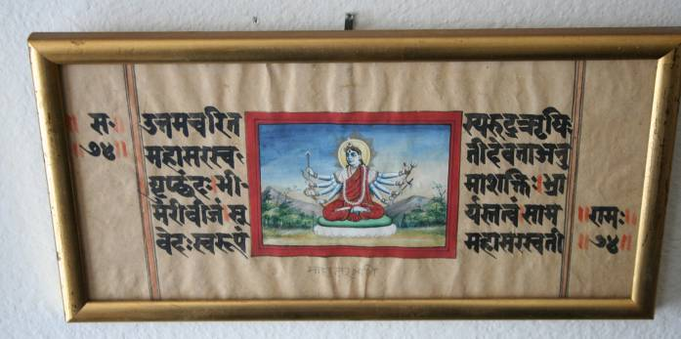
Another example of East Indian Sanskrit with Indian Goddess.
Measures 11.5 x 5.5”.

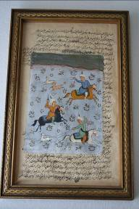
Arabic Writing…We know nothing about the substance or age of this text. Hand written with painting overlay.

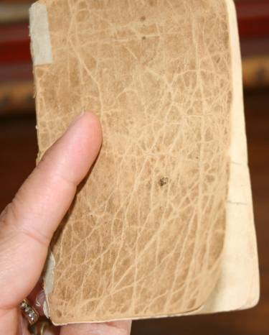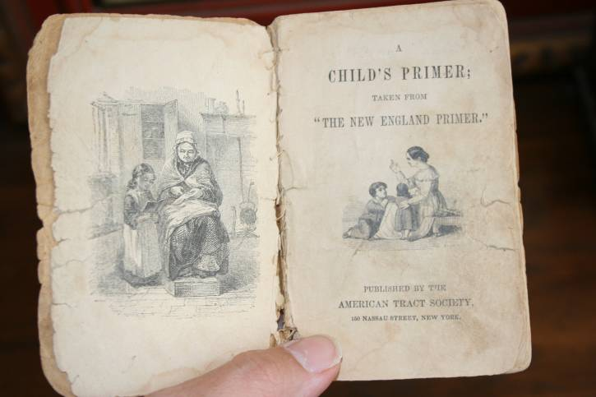

“The New England Primer” published by the American Tract Society, 150 Nassau Street, New York. Looks really old, probably 18th Century. “Very Rare” (Columbia Encyclopedia).

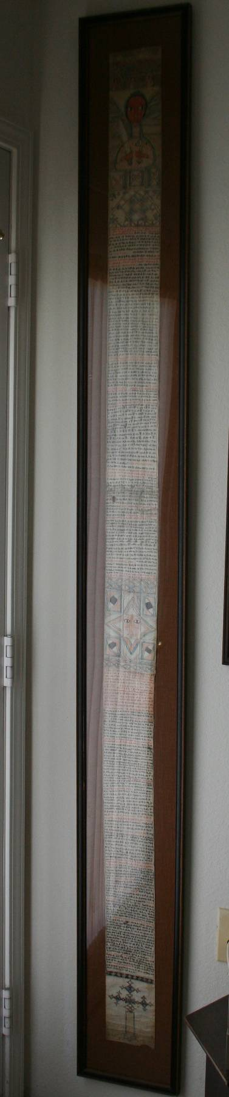
Coptic Ethiopian Scroll Age unknown, handwritten
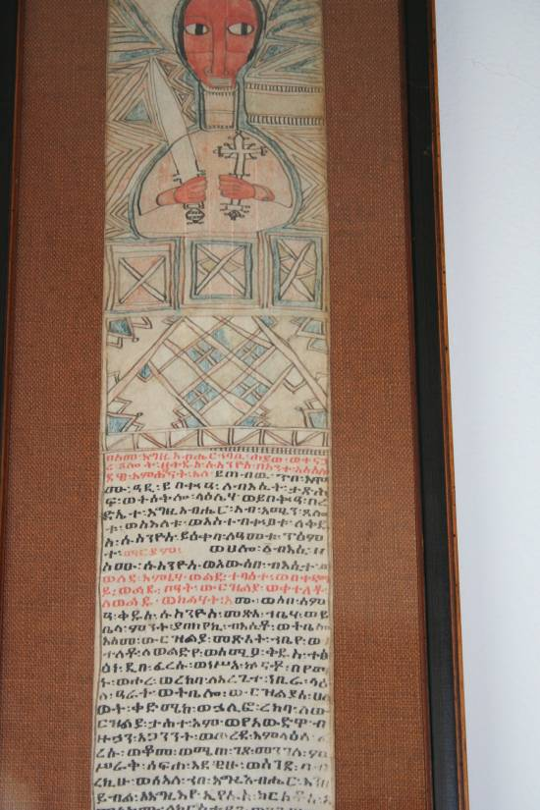
“Coptic”, an Afro-Asiatic language descended from ancient Egyptian.
Used as the liturgical language of the Coptic church” (Webster’s 7th New
Collegiate dictionary) 80” tall by 4.5” wide”. Purchased in Laguna Beach

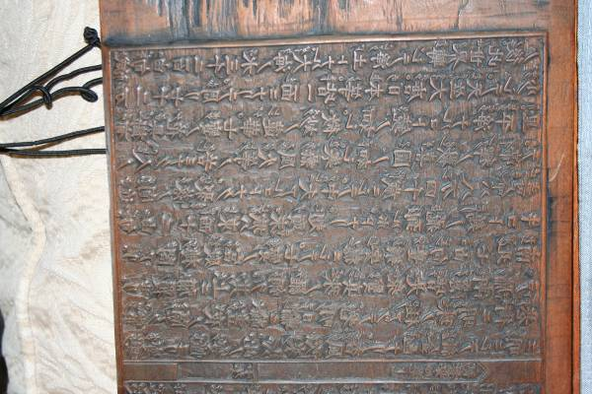

Japanese Printing Board of Religious Text
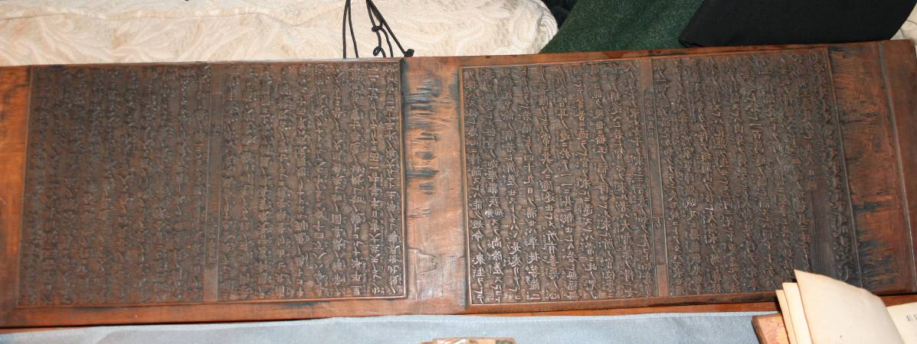
Date unknown, measures 31” x 8 “. Two-sided with 4 pages on each side. All symbols carved into the wood. (A student I had in my “Writing, Printing and Libraries” class asked to borrow it saying that his wife’s father was a Japanes scholar. He reported that the text was religious one. He also gave me a printing from the board. But, it eventually became so shabby I had to dispose of it.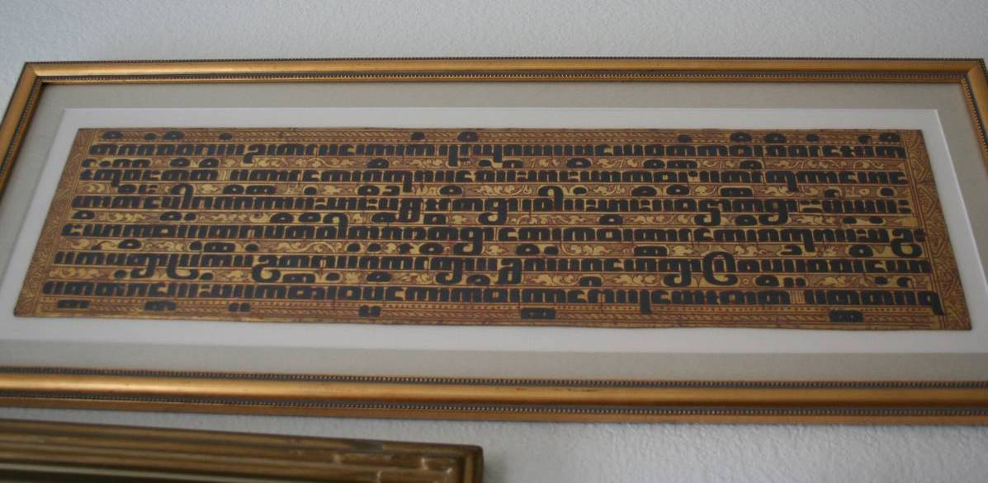

“Burmese Bible Page Written in Pali” on gold-surfaced palm leaf (not ancient). Measures 21” x 5.5”

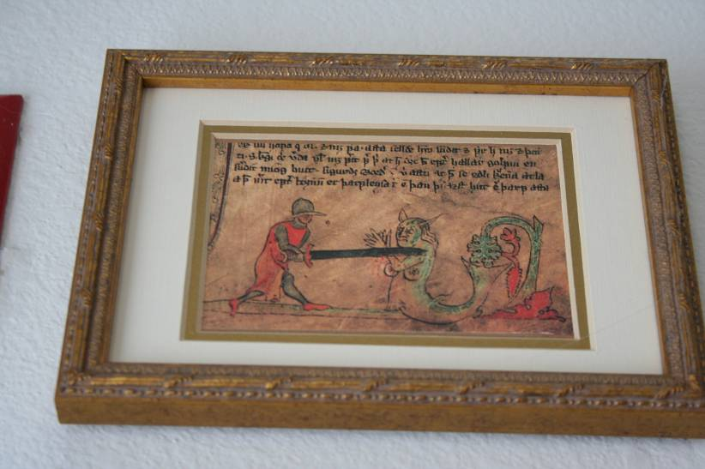 Runic Writing Example from book of Icelandic Sagas.

